Logic Design 2DI4

Lab #3

Lab TAs: Kamel(baratik), Zubair(emonm),

Maruven(Fetteha), Neha(bhattacn)

Jamin Xu – L09 – Group 80 – xu826 - 400557470

Kyle Rebello – L09 – Group 80 – 400590059- rebellok

As a future member of the engineering profession, the student is responsible for performing the required work in an honest manner, without plagiarism and cheating. Submitting this work with my name and student number is a statement and understanding that this work is my own and adheres to the Academic Integrity Policy of McMaster University and the Code of Conduct of the Professional Engineers of Ontario. Submitted by **[Jamin Xu, xu826, 400557470]**

As a future member of the engineering profession, the student is responsible for performing the required work in an honest manner, without plagiarism and cheating. Submitting this work with my name and student number is a statement and understanding that this work is my own and adheres to the Academic Integrity Policy of McMaster University and the Code of Conduct of the Professional Engineers of Ontario. Submitted by **[Kyle Rebello, rebellok, 400590059]**

**4.1**

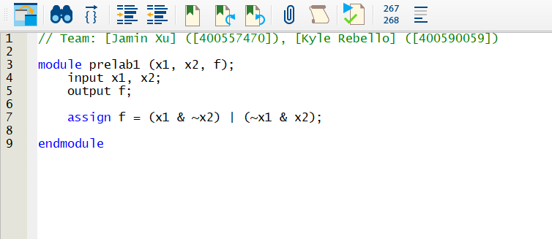

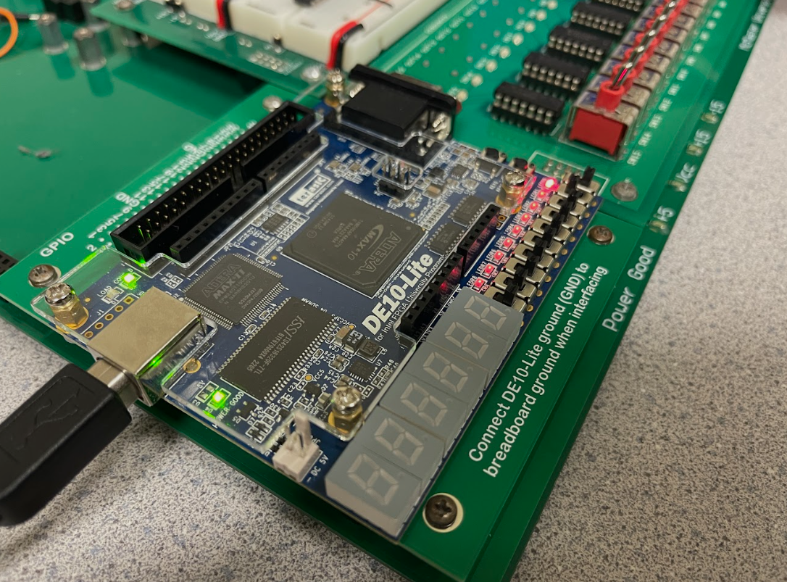

**4.2**

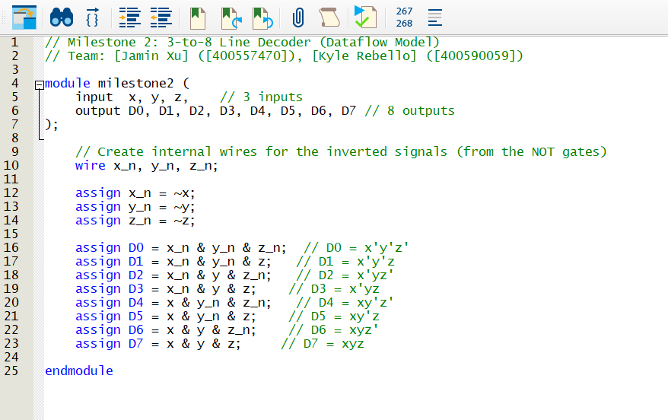

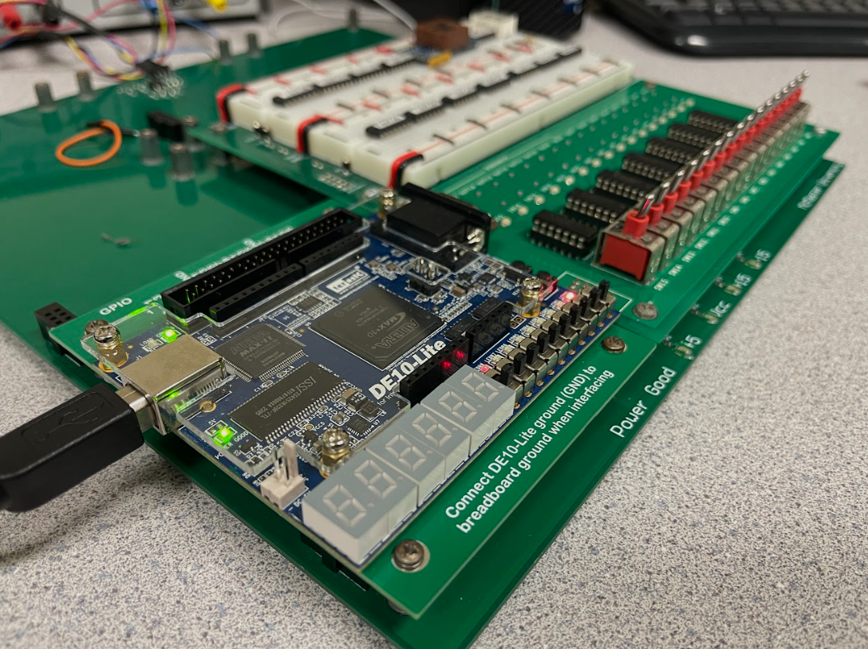

**4.3**

**